**The Truth About Wellness: Executive Summary**

**Introduction: The Age of Wellness…**

In many ways, The Age of Wellness is well and truly upon us. ‘Wellness’ is a concept so rich with possibility that it is shifting from a perceived luxury to being considered a fundamental human right. Spending on wellness has doubled in the last decade, and will continue to grow at an impressive rate.

With global healthcare at crisis point and consumers picking obesity as the number one threat to the future health of humanity, you might argue that it is the very worst of times for our overall health and wellness.

And yet, there is much to be positive about: 86% of people believe they have the power to change their own level of wellness, 73% feel positive about their overall health and the average person now believes they will live to 79 (in China this rises to 84). This optimism is being amplified by a technological revolution that is set to dramatically impact our health.

**Brands: seize the day**

There has never been a better time for brands to shape the future of wellness and to assist consumers in their quest to live better and healthier lives. The global interest in, and confidence about wellness, is poised to impact everything about the way we live our lives, from the products we buy to the places we work and play.

The brands that consumers felt had contributed the most to wellness in a positive way came from a variety of categories: Nike, Subway, General Mills, J&J, Nestle and Adidas were amongst the top rated. This reflects the multidimensional nature of wellness itself. The brands that are most valued in this space are finding simple ways to inspire and support consumers.

In order to provide brands with these vital strategies, McCann Truth Central conducted quantitative research with 7,000 consumers globally in US, UK, Japan, China, Turkey, South Africa and Brazil. This was supplemented by co-creation workshops and expert interviews in US, UK, Japan, Brazil, Peru, India, Mexico, Thailand, South Africa and Chile.

**What is ‘wellness’ exactly?**

…But before we dive headlong into a deeper exploration of the concept it is worth pausing to explain what we (and consumers) understand by the word.

The World Health Organization defines it in the following way:

*Wellness is an optimal state of health. It concerns a person’s individual health physically, mentally, emotionally and spiritually and also their role in society and fulfilling expectations in their family, community, place of worship, workplace and environment.*

In the survey we asked consumers to indicate the relative importance of the components that are thought to make up our overall wellness. As you’ll see below, the primary emphasis is on physical health but consumers certainly see wellness as a multifaceted concept:



This overall understanding of wellness was fairly consistent from country to country but the perceived route to wellness differs somewhat. For example, in the UK, US and South Africa, people believe that it is easier to achieve wellness without children whereas in China and Japan it is easier to achieve wellness with children.

Globally, the optimal age to achieve wellness is 34 (although in Turkey it is 23 and in Japan it is 44). The countries deemed to have the healthiest people overall are Japan, China, Switzerland and the US. And interestingly, people are twice as likely to agree that it is easier for women to achieve wellness than men.

These differences aside, there is no doubt that wellness is starting to touch everyone and everything. It is fast becoming an all-encompassing belief system that has the power to transform everything about the way we live our lives in the 21st century.

**1). The Wellness Enemies**

Wellness is a journey rather than a state which means that even if we rate our overall health positively, the majority of people would like to be ‘more well’ than they currently are. Yet achieving wellness isn’t always that easy. There are some nasty barriers that seem to get in the way and stop us from achieving our wellness goals. We call this the Axis of Evil…

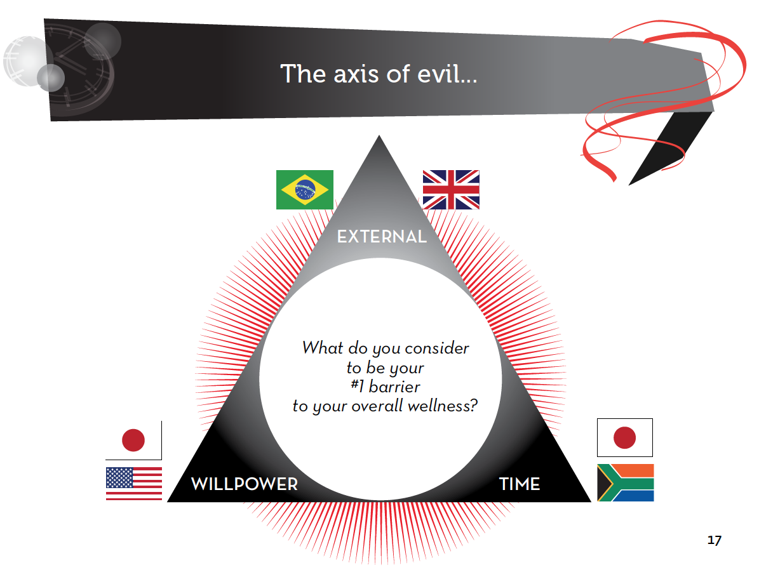

Firstly, people look to blame external factors: namely the economy and the environment.

Over a third of people say the wellness of their family has suffered since the onset of the global financial crisis and pollution is seen as the single biggest threat to the future wellness of humans in China & Turkey. Consumers clearly perceive that the world provides many obstacles in their quest for wellness, as one US respondent said; “you have to fight for your health now.”

**Enemies closer to home**

The other enemies in the axis are closer to home, ‘lack of time’ and ‘willpower’. In co-creation workshops, consumers were asked to bring a picture of their number one wellness enemy and many brought a picture of a clock. From South Africa to Brazil, people felt that they had somehow lost control of their time. In today’s multi-tasking, multi-screening societies, we layer activity upon activity. Stress levels consequently run at a constant high – a high that ultimately compromises our physical and mental health. Indeed, consumers felt that ‘being constantly stressed’ was the factor most likely to make an individual sick in the future (ahead even of smoking and drinking too much).

Many consumers also pointed to a ‘lack of willpower’ as being the fundamental barrier to their own wellness. As one respondent in the US stated, “My number one enemy to my wellness is myself”.

**Mental health and brain health on a par with physical health**

It is interesting to note that our wellness enemies are deeply psychologically rooted; this reflects the growing interest in mental / mind health amongst consumers and experts.

For many years, mental health was a taboo and not a subject that the majority of people felt willing or happy to discuss. It is significant that people today rate their combined mental and emotional health as outweighing their physical health. A growing awareness of mental health issues is indicated by the fact that 1 in 10 people say that they have diagnosed themselves with depression after looking on the Internet.

Forced to choose, UK, Brazil, US, South Africa and Turkey would even preserve their mental health over their physical health. Unsurprisingly, the aging market of Japan is the country where people are most concerned about Alzheimer’s. It is perhaps more surprising that 49% of people globally say that they do exercises to improve their brain health (60% of Brazilians and over 70% of Chinese).

**Brands: Sponsor one positive habit**

Fighting these enemies alone is a tiring task for the individual…so what can brands do to help? Our research suggests that consumers sometimes place too much emphasis on their own willpower and over-commit to a raft of unattainable goals. As David Kirchhoff, Weightwatchers CEO, recently stipulated, “You have to start making healthy choices automatic…willpower is completely overrated, it just doesn’t deliver”. Recent research suggests that adopting just one healthy change can have a knock on effect in multiple areas of your life.

Weightwatchers recently launched their 360 Degrees plan which aims to provide people with simple tools to regulate their spaces and routines and encourage weight loss (i.e. a guide on how to rearrange your cupboards) rather than placing the entire emphasis on the individual’s willpower.

Subway is a top rated wellness brand in the US and they successfully aligned themselves with one healthy habit via Jared The Subway Guy who lost a significant amount of weight after replacing his meals with Subway. His story is still celebrated and promoted via the Subway website.

**2). The Wellness Heroes**

Luckily, consumers also believe they understand the key ingredients in order maintain their future wellness. We call this the Axis of Goodness.

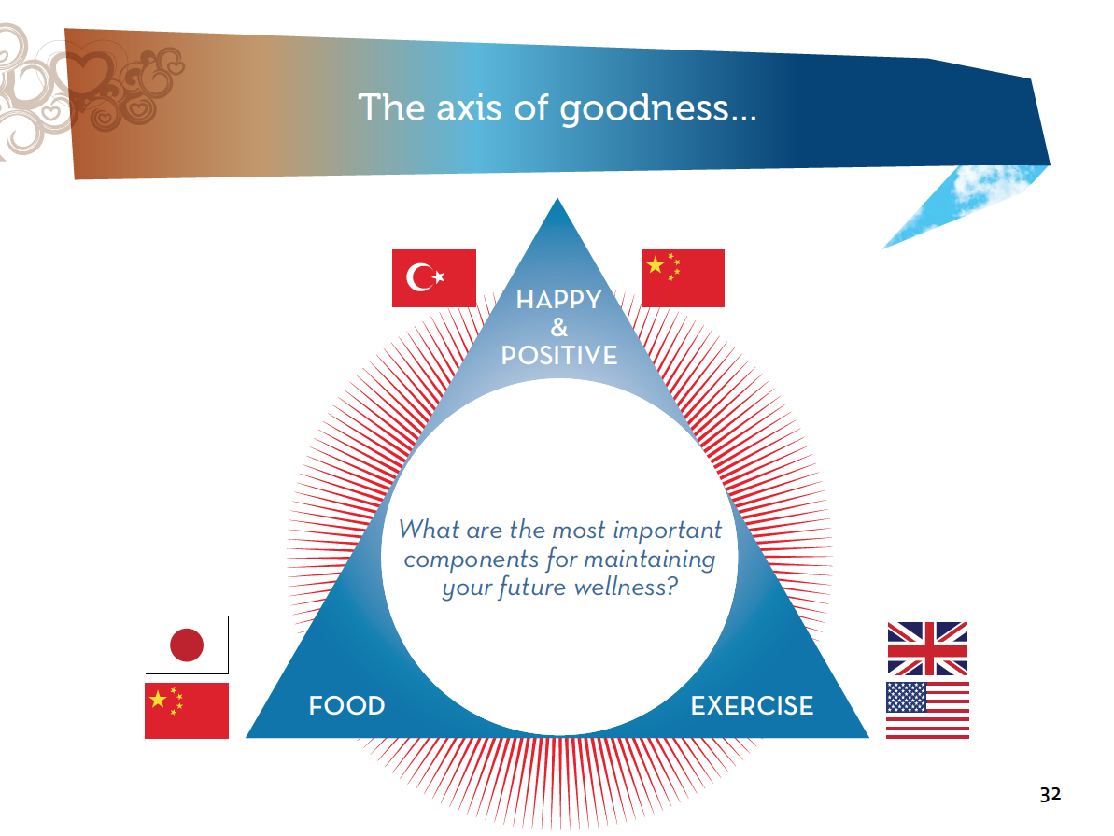

Our wellness heroes are ‘remaining happy and positive’, ‘eating the right food’ and ‘getting enough exercise’. When it comes to the wellness of their children parents say that ‘a balanced diet’ is the single most important component followed by the ‘right amount of sleep’ and ‘regular exercise’.

Consumers are excited about food and even equate it to a kind of wellness elixir. 59% believe that we have yet to unlock the potential of food and consumers are full of ideas about magical ingredients like salt yeast and turmeric that will protect them from all manner of ills. On the positive side, people are focused on the right things when it comes to their wellness; i.e. adopting a healthy, balanced diet and moving more. Unfortunately, the reality surrounding these simple building blocks is a little more complicated…

**Our heroes can also be our anti-heroes**

1 in 5 consumers describe mealtimes as ‘a battle in my head’, a third think about food more than sex. Despite (or perhaps because of) a deluge of information on diet and nutrition, globally, consumers still aren’t in agreement about what’s good for them and what isn’t. Overall, coffee is deemed to be worse for our health than chocolate (but in Japan and UK it is thought that chocolate is worse). Meat is generally thought worse than dairy but the gap is much more significant in Turkey, Japan and Brazil. Salt is worse than sugar in China, UK, Japan and Brazil but sugar is seen to be worse than salt in US, S.A and Turkey…

We see similar contradictions surrounding exercise. 75% of people would describe themselves as fairly or very active and yet according to the Lancet, Physical inactivity is the 4th biggest killer worldwide. In essence, our relationship with the simplest components of wellness (food, exercise) has become complex and could benefit from being fundamentally reset.

**Happiness unites us**

There is one thing that unites us all: the belief that ‘remaining positive and happy’ is the most important ingredient in maintaining our overall health and wellness. Thanks to an abundance of literature on the topic as well as brand messaging, ‘Happiness’ has certainly become a dominant idea in mainstream culture over recent years. Yet despite all of this information on happiness few consumers believe that we’re getting any happier! It seems that ‘happiness’ has become another source of worry for people…with many asking themselves “Am I happy enough?” “Are my children happy enough?”

**The dark side of wellness**

In truth, the story of wellness isn’t purely one of relentless positivity and purity. If one does a Google image search on the word ‘wellness’ you will be confronted with a sea of serene looking women doing yoga by the side of a river, spa resorts, green meadows and happy couples.

Which fails to acknowledge that wellness as a concept has a darker side, one that recognizes that bad can be good. Consumers are quick to point out that a cookie, an occasional cigarette or a bottle of wine with friends can be a vital part of helping you to feel well. Consumers aspire to a harmonious vision of wellness that embraces the dark with the light.

**Brands: Celebrate and simplify our relationship with our heroes**

Brands need to act like compasses and help to reset the complex relationship consumers have developed with things that should be simple: food and movement.

In 2012 Chipotle created a campaign that set to dramatize for consumers how the food chain had become unnecessarily industrialized and complicated. In a simple animated film Chipotle sets out their commitment to going back to the basics of food quality and sustainable production.

**….From the present to the future**

Hopefully the story of our enemies and heroes, i.e. the economy, the environment, willpower, time, food, exercise and happiness provide an insight into the status quo for wellness and our personal demons.

In order to understand the future we must explore the forces that will shape wellness in the years to come. There are two emergent themes that were much discussed by the expert interviewees: An expanded wellness ecosystem and the impact of wellness technology. We believe these forces will combine to provide a more Integrated Wellness vision for our future.

**3) An Expanded Ecosystem**

From influencers to platforms, the wellness ecosystem is expanding. But the consumer remains firmly at the center. When asked who has the greatest amount of responsibility for wellness, the first answer is ‘me’ (ahead of doctors, government or brands). Overall, we see that consumers have a new confidence and self-belief when it comes to managing their health.

This in turn is impacting everything from the consumer’s willingness to self-medicate through to how they manage their relationship with the doctor. In the past, the journey ignited by an ailment was far simpler; if you felt ill you would most often go straight to the doctor and the doctor was the center of everything, it looked something like this:



Nowadays, the patient is at the center of his or her own ecosystem and the doctor is one influencer amongst many:



**It’s not over for the white coats yet…**

Although 21% believe that one day technology will render doctors unnecessary the vast majority still place significant faith in medical professionals and many would even welcome an expanded role. In fact, 66% agree that doctors should focus more on prevention as opposed to curing illnesses.

The ecosystem depicted above also hints at the increasingly social dimension to wellness. Prior to or post diagnosis many will seek a patient or like-minded community to share tips and advice. More and more, people are able to determine and build their own wellness infrastructure based on their collective needs.

**It’s not me…it’s you…**

More generally, people also understand that their wellness is greatly influenced by the health and wellness of those around them. Half of people agree that being healthy is about “who you’re with and where you are”.

**A social conversation as well as an individual conversation**

There is an opportunity to approach wellness at a community level and beyond. Brands can act as the conduits in this arena, helping to enrich the consumers experience in the new ecosystem.



**Brands: find novel ways of entering the wellness conversation**

General Mills’ Nature Valley is a great example of a brand adopting an idea far beyond the nutritional value of the bar. The pioneering brand found a novel and creative way of dramatizing their strategy of bringing the individual closer to nature.

They sent teams throughout Yellowstone, Great Smoky Mountains and the Grand Canyon this past summer to digitally capture 100 miles plus footage of each location. People can experience a personal view of hiking these trails from their laptop or iPad as well as enjoying embedded content like videos. At a time when people feel divorced from nature…their trail view initiative makes wellness accessible in a whole new way.

“Nature is something you have to get close to in order to be moved by it,” says Scott Baldwin, Senior Marketing Manager at Nature Valley. “It’s easy to just show a picture of nature, but people want to have deeper experiences.”

**4). Wellness Technology**

There is no doubt that technology is set to have the most transformative effect on our future wellness. The positive elements on our health cannot be denied:

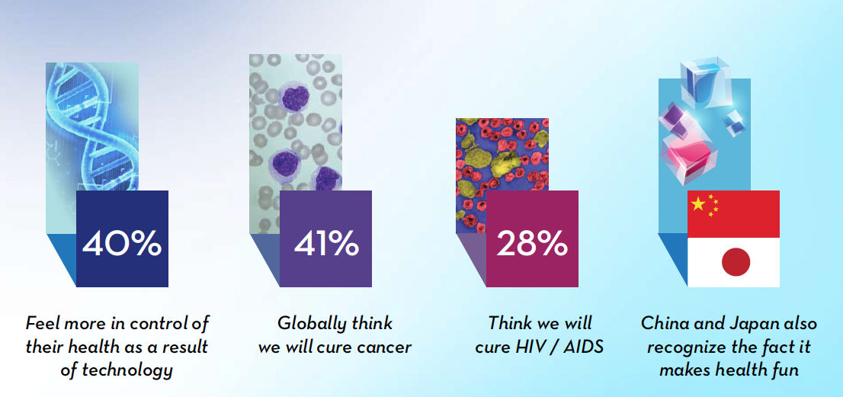

There has been much discussion about the fact that innovations such as in-built sensors and 3D printing are set to revolutionize the way we measure and manage our health.

**When science fiction becomes a reality**

Many consumers would welcome a future where technology and science make extraordinary things possible. 32% would like to remain the same age forever, 26% would like to erase unpleasant memories, 18% would insert a microchip to constantly measure their health and 12% would eliminate their need for sleep.



**Humanity versus technology**

However, you cannot deny that in the face of such change, there is much trepidation surrounding technology and health. Consumers characterized technology as a “space away from space” that “consumes” them. The sense of it being unnatural and separate from their lives highlights the root of the tension: the overarching fear is that as technology becomes more sophisticated, we will lose something fundamental to our humanity and our wellness, be that our privacy, our control over our time, our ability to have real conversations or the power of touch…

And this is where the dichotomy lies, 54% of the world’s population believes that technology will ultimately make us more well, but 46% think it will make us sicker. The tensions around health and technology are far from resolved and brands must work hard to create a frictionless and human way to utilize the clear benefits technology brings.

**Brands: re-imagine technology in a human context**

When L’Oreal launched an app for the Xbox 360 Platform they focused on the human side of health and beauty in terms of the tips, opinions and tricks that young women are hungry for. Consumers have the ability to customize their experience and receive tailored beauty product recommendations as well as unique how-to content and video tutorials.

“With more content and women on Xbox LIVE than ever before, we see this as a tremendous opportunity for L’Oréal USA. We wanted to connect with this rapidly growing audience and combine their passion for entertainment and beauty into one seamless personalized experience.” said Esohe Omoruyi, VP Digital Marketing L’Oreal USA.

**5). Integrated Wellness**

In our workshop groups, we asked people to draw what a “well person” in 2020 would look like. The clear tension defining the future of wellness was starkly depicted with half of the groups drawing a robot-like man and the others drawing a Zen-like, relaxed meditator. We see a tale of two conflicting futures:

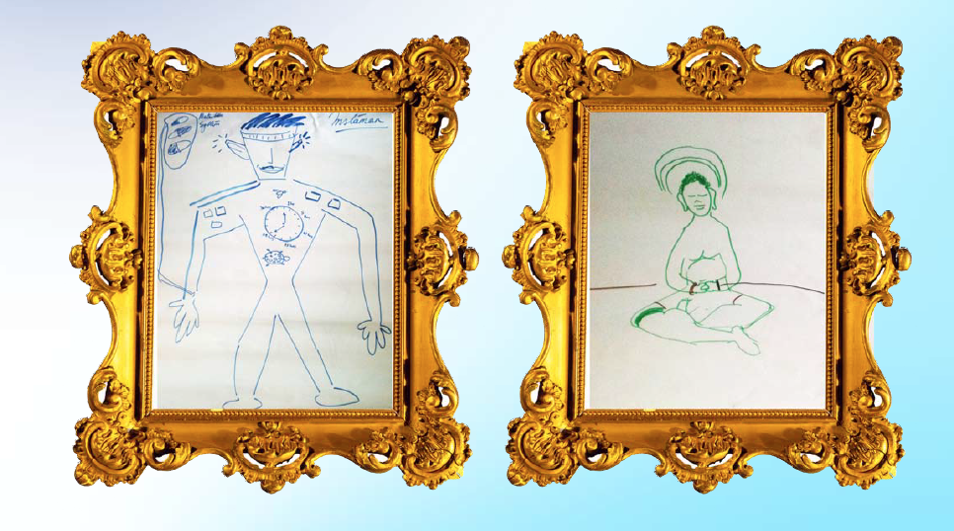

These images hint at two competing forces…where progression and technology subsume humanity versus the desire to pare back and simplify our existence.

Brands and companies must strive to seamlessly integrate wellness into consumer’s everyday lives. Despite the fact that the number one way people describe wellness is as “a way of life” when we asked consumer draw what wellness looks like in our workshops their depiction was something like this one taken from Brazil:



Consumers still think of wellness as something that only exists in certain places and times. If we want to create a positive vision for our future then wellness must be seen as a life long journey, not a simulated, short-term goal. Wellness as a way of life is a commitment that must be made across all aspects of consumer’s lives: from adopting integrative medicine, to designing environments that promote wellness. In order to achieve this, brands need to rethink all areas of their business, both external and internal. In so doing, brands can be a key conduit for enabling consumer adoption of wellness.

**Brands: Position wellness in the everyday**

Molico (Nestle) in Brazil took the opposite approach to its main competitor when they showcased women as “day-to-day athletes” by celebrating their normal activities. This placed the brand in the everyday and showed that wellness was something that could be achieved outside a perfect world.

Another example would be a ‘wellness company’ like Ikea. Ikea is a brand that has been supporting the notion of living well and a wellness ethos for many years and they integrate wellness into everything they do; “At IKEA our vision is to create a better everyday life for the many people.” (Ikea.com).

One of their most recent innovations, the New Ikea catalogue, combines augmented reality with the comfort and tradition of the paper catalogue, thereby delivering the latest technological innovation in a very human way.

**6). Conclusion**

74% of consumers think that wellness is going to become more important in the future and yet rising levels of diabetes and other rich-world diseases indicate that we’re also at a time of crisis. Yet a crisis can often trigger a time of creativity and entrepreneurialism. There has never been a better time to be an innovator in the health and wellness space.

As the research indicates, many of our wellness heroes and enemies (time, willpower, food, exercise and happiness) are deeply personal and represent the struggle of the individual. Yet our solutions will be both personal and collective. In the new wellness ecosystem, technological innovation has the power to transform so much about our health.

It is undoubtedly true that wellness has become a complicated area for consumers; in many ways they are empowered and increasingly knowledgeable yet often they are confused and seeking help. 57% of people wish they had more support in leading a healthy life, especially in the emerging markets (88% in China and 73% in Brazil). Young people want most help: 61% of 18-34s want support versus 44% of 55+. Brands are perfectly poised to provide the help and advice that consumers need.

**Well Brands**

By acting responsibly and creatively brands can be part of the solution to the world’s health and wellness challenges rather than part of the problem. We believe that brands can forge a positive path in the world today by adopting some straightforward mantras and co-creating a Well Brands Manifesto to navigate this time of complexity.

**The Well Brands Manifesto**

1. Help to defeat our wellness enemies by sponsoring one positive habit
2. Celebrate and simplify our relationship with the wellness heroes (food, exercise)
3. Find novel ways to enter the wellness conversation
4. (Re)Imagine wellness technology in a human context
5. Position wellness in the everyday

Whilst the wellness conversation might be more immediately relevant to health and fitness brands, in truth, wellness is something that is going to increasingly touch every consumer and every product.

Eventually every company will be a wellness company and can benefit from the principles above.

To find out more download the full Truth About Wellness report at truthcentral.mccann.com

Distributed by McCann PR

Beverley Bradley

+27 11 235 4635

+ 27 72 272 5166

[beverley.bradley@mccann.com](mailto:beverley.bradley@mccann.com)